
brojed.org
brojed@aol.com
cell:573-999-0347
573-999-0347
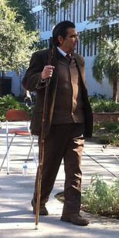

THE GIFT WHICH I NEED
January 4, 2011
“I will give you the ability to speak, along with wisdom, that none of your opponents will be able to resist or refute (Luke 21:15).” I am laying claim on this promise as we begin the New Year on campus.
Today, Martha and I started preaching on the public sidewalk in front of the Student Center at the University of Alabama, Birmingham. Jesse Morrell recommended UAB as one of his favorite campuses. I have not been on the grounds for over 30 years when I was with the late Brother Max Lynch. As I recall, we ran into problems with the authorities that day and did not stay long. I had not been preaching five minutes when the Assistant Vice President for Student Life introduced himself. He was a friendly gentleman and said he approved of what we were doing. He instructed us to stay on the public sidewalk. I did not argue with the restriction since it was a good location. He told me that after lunch there was not likely to be too much activity since most of the classes are scheduled in the morning. Also, on Tuesday and Thursday classes are 75 minutes long. I preached for 30 minutes and was not connecting with the students, although several stopped to listen for a short time. By 12:30 the flow of students had ebbed. I did not want to wait for over an hour for another break since from what the administrator said it was likely to be small. I thought Troy University was only an hour south on route to our Florida destination. So I decided to try for a double header. However, when we got on the road I discovered that Troy was two and a half hours south. By the time we arrived it was 3:30 PM. Nevertheless, I stood outside the Student Center holding my colorfully illustrated list of sins sign to a few passing students. A girl walking with a boy admitted that she was a rebellious woman. I admonished her and we exchanged a few comments and she walked on. At 4 PM, we got back on the road and drove to Mariana, Fl, which is about 90 minutes from Tallahassee, which is our destination for tomorrow.
It was a disappointing day especially after Jesse’s report. But it was a cold day, especially for Alabama, only in the low 50’s and cloudy. Also the first day of classes usually makes things more difficult because students are getting resettled and tend to be preoccupied.
Today was my birthday. I am thankful for the opportunity to grow old. Many I have known have not had that privilege. Craig Rogers mentioned that I look like I am 48 instead of 68. I can say that I do not really feel that much differently than I did at 48. If anything, I feel healthier since I am in better condition as a result of losing weight and a daily exercise program over the last few years. I am thankful that I have not had a serious health issues over my many years. I have never been on medication for a prolonged period, except for the ibuprofen I took for about four months to relieve the pain of my pinched nerve this past year. I am now recovered from that ailment. I have never taken any drugs for my mental health and cannot imagine doing so, being as I am of a sound mind. I have had what was diagnosed as kidney stone attacks twice in the past thirty years, but these passed without surgery although not without considerable pain for hours. All of this is remarkable because from the time I was fifteen until my conversion at twenty-nine I abused my body first with an excessive use of alcohol and later promiscuity and drugs. Yet the Lord has restored “the years that the locust, the cankerworm, and the caterpillar, and the palmerworm hath eaten (Joel 2:25).” I am so thankful for his grace and mercy and recuperative powers to this chief among sinners. I believe in the divine health and prosperity. And I also believe in suffering for righteousness’ sake.
Moses spent 40 years in the backside of the desert and at 80 years old the Lord appeared unto him in the burning bush and he had another 40 years leading his people out of slavery, through the wilderness and to the top of Pisgah, where he saw the promised land before the Lord took him home. I have been for a daily voice crying in the wilderness on the campuses to would be intellectuals since 1974, and even just after my conversion in 1972, so I am approaching my fortieth year of ministry. I have always felt that before it was all over that God was going to give me a place in the sun for some years to do a larger work for him among God’s people. I have no plans to leave the barren wasteland of our Wisdom rejecting universities. Wesley, after being shunned by the churches for most of his ministry, in his later years was accepted by the same churches which had once rejected him. Of course, he had much more visible fruit from his wilderness ministry than I have had. We shall see what the Lord brings in the time remaining for me. The church world desperately needs leaders to show her the way out of the bondage of sin into the freedom of holiness and entire sanctification, that she might learn boldness and to be a fearless fighter against sin and iniquity. Right now I feel like I could go another 40 years but that is probably not realistic. For I know that death is constantly stalking us all. So either way, whether here or above, I will have my place in the sun as I remain faithful unto the end. And so shall we all.
I thank the Lord for my dear mother who delivered me and nourished me. She was the first one to tell me about Jesus. Before going to bed, I said my prayers at her knees until I was eleven. Then someone made of fun of me and told me that I was too old for that. As a result, I stopped praying and everything started going downhill (especially morally). She was one of the finest examples of a Christian woman that I have known. I look forward to meeting mother again in heaven before long.
True Grit Review
January 5, 2010, rained out.
Martha and I went to see the film True Grit, which is introduced with a quote from Proverbs 28:1, “The wicked flee when no man pursues:”
The narrator’s opening line is, "People do not give it credence that a fourteen-year-old girl could leave home and go off in the wintertime to avenge her father's blood but it did not seem so strange then, although I will say it did not happen every day."
When 14 year old Mattie starts on her great adventure to revenge her father’s murder, she declares, “My father would want me to be firm in the right, as he always was,” she resolves, quoting the 23rd psalm (“Yea, though I walk through the valley of the shadow of death…”). “The Author of all things watches over me,” she concludes, “and I have a good horse.” Faith, a good horse, and two gritty lawmen is all that she needs to fulfill her goal that her wicked antagonist, Tom Chaney, gets what he deserves.
Is there justice in the Wild West? Is there difference between justice and vengeance? Does the Author of all things see? In an opening monologue Mattie declares: “No doubt Chaney fancied himself scot-free, but he was wrong. You must pay for everything in this life, one way and another. There is nothing free, except the grace of God.” In the end Chaney pays for his crime and Mattie suffers for her vengeance, all in the same action.
It is inspiring to see a 14 year old girl portrayed by Hollywood with faith, courage, gumption, maturity, modesty, a business sense and resoluteness. The time is post-civil war America long before the terms “teenager” or “adolescent” were coined.
My 16 year old daughter, Priscilla Liberty, recently organized a “Do hard things” conference aimed at youth. Mattie, the 14 year old protagonist in the remake of the John Wayne film, demonstrates the character qualities that Priscilla’s conference promoted.
The film might well have concluded with the rest of the verse from Proverbs 21:1, “but the righteous are as bold as a lion.”
Dylan Whatley posted on my facebook wall today, “A belated birthday, Brother Jed. Know that even among us unbelievers, you have made a mark simply by being a man of conviction. Where other hearts wither and falter, you pursue what you feel and know to be true, and this makes you beyond admirable in every respect.”

INTO MY WEB
Florida State University, January 6, 2011
I preached over 30 minutes without any response although several people were sitting on benches apparently listening. Finally, a male who had been sitting on the wall said, “I am the anti-Christ.” I replied. “I can believe that you are against Christ.”
We started bantering at one moment he was claiming to the devil then he would claim to be God. My confrontation with the child of the devil drew others into my web. A fellow holding a banana said, “We need to worship the banana. We cannot live by banana bread alone, but by bananas. You should eat a banana everyday for nutrients.” I ignored him and continued preaching. Later he return and I did not try to preach over him but let him rabble on because I suspected that he would run out of gas.
At times the crowd reached well over a hundred. After 5 PM, there were still 25 encircled around me asking questions. I did not leave campus until 6 PM. The weather was cloudy and only in the fifties. I considered it to be an outstanding day.
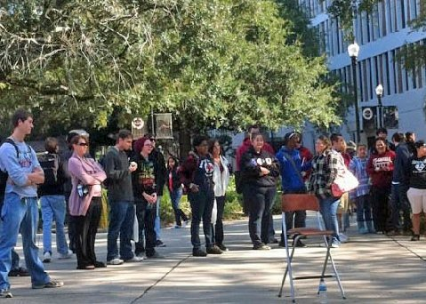
"I considered it to be an outstanding day."

"After 5 PM, there were still 25 encircled around me asking questions."

SOUL WINNING SHOULD HAVE PRIORITY
Florida State University, January 7, 2011
At Methodism's organizing conference in 1784, preachers were advised never to let study interfere with soul-saving: "If you can do but one let your studies alone. We would throw by all the libraries of the world rather than be guilty of the loss of one soul." (1784 Discipline) It should be noted that John Wesley himself was a graduate of Oxford.
I had not been preaching but for a few minutes when an atheist, Nick, and a few of his friends, one of whom carried a ukulele and wore a harmonica around his neck gathered around me. The fellow with the musical instruments would put into song my message. He was good at improvising and his antics helped draw a crowd, which was never as large as yesterday but pretty good for a Friday afternoon.
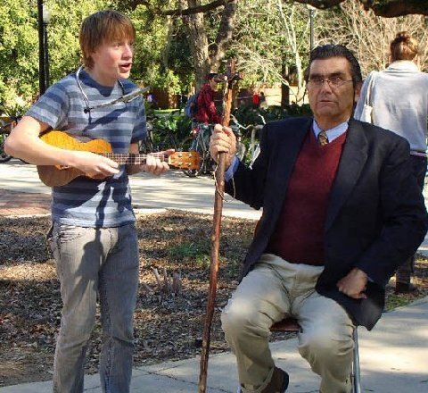
"The fellow (atheist) with the musical instruments would put my message into song."
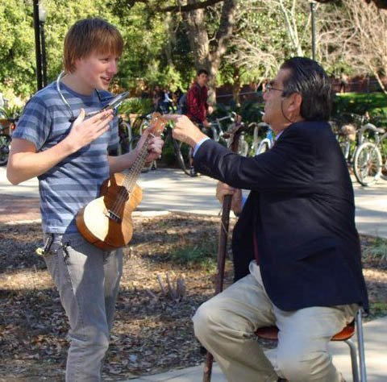
"He was good at improvising and his antics helped draw a crowd..."
Two promiscuous girls who had listened most of yesterday spent most of the afternoon with me. They indicated it did not make any difference whether they had sex with a male or female. They both grew up in the Lutheran Church, one of whom had even gone on mission trips. Both had burr haircuts, one of them kept blond bangs and had many facial piercings. Both of these girls were unusually pretty and seemed to have had some good breeding. The girl without the bangs gave up her religion when she came to college and she said that she had the same good feelings from doing social work as she did Christian missions. So she assumed that the feelings she had while working in church was not from God but was essentially a social reaction. I explained the true religion was not about feelings but Truth and especially the Truth of the New Birth. She had not been taught about the New Birth in church. Also, in your mainline churches mission projects have essentially become social projects with little or no attention to soul winning. So really there is very little difference between social work and church mission programs today. I told the girl with the blond bangs and piercings that she had lost all sense of dignity. She resented that, but then said, “Define dignity.” I replied, “A sense of honor and self-respect.” Obviously, you have no respect for your body or you would not just give it to anyone and you would not have buzzed your hair and pierced your face.” She dropped the F-bomb on me and stopped off saying “so, if I am going to have dignity I need to let my hair grow and stop f_______.”
There were times today when the crowd was quite attentive and generally civil. One other girl late in the afternoon got into my face for telling her she had no sense of dignity or she would not use the gross and vulgar and uncreative metaphors which I cannot repeat. I thought she was going to hit me. But the boy she was with restrained her.
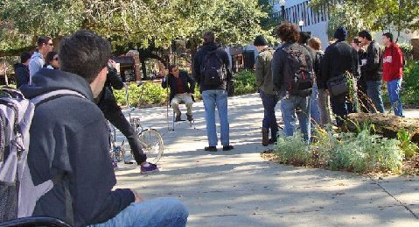
"There were times today when the crowd was quite attentive and generally civil."
By 3 PM I only had about 8-10 listening. So I decided to call it a day since we had a 90 minute drive to Mayo, Fl. Several that were remaining extended some warm parting words. One fellow told me as we walked off, “I appreciate and agree with what you are doing.”
Nick, the atheist, constantly asked me about evolution. He was in the audience most of yesterday and all of today. He claimed that the fossil record proved evolution. I asked, “How?” He never did give me an answer, except for repeatedly citing Richard Dawkins. He evidently thought by quoting a scientist he proved his point. Of course, he refused to consider Bible writers as evidence for Creationism. I gave him a copy of Who Will Rise Up? I rarely give the book away any longer because I have only about 100 copies left in print. Pray that the book will reach the lost soul.
In the evening Nick wrote on my wall, “I think your religious beliefs are unscientific, but I have to admit I respect that you're consistent and I believe your intentions are good. I look forward to your next visit to FSU.”
I answered, the World English Dictionary defines science as “the systematic study of the nature and behavior of the material and physical universe, based on observation, experiment, and measurement, and the formulation of laws to describe these facts in general terms.”
My teachings are not based in physical science. I am not essentially teaching about the material and physical universe. I am teaching on the spiritual universe. I am teaching metaphysics, not physics. The primary tools of the scientist are the five senses. The main tools of the metaphysician, theologian and philosopher are authority, intuition, reason and experience. My primary authority is the Bible. Your primary authority for defending evolution this afternoon was Richard Dawkins, you referred to him time and again. In another generation I suspect that he will be pretty much forgotten and rarely quoted. However, for generations to come men will still be citing Moses and other Biblical writers, as they have for millenniums past.
Evolution is counter-intuitive. If man is merely a late and insignificant byproduct of time, chance and matter, he lacks dignity and significance. He merely rises from the primordial ooze, and soon melts back into the mud from which he came. We all instinctively know that man has dignity and significance. The butch with the blond bangs was insulted that I had questioned her dignity. She was mad because she intuitively knows her life has significance and dignity, even if she cannot articulate what it is. Hence, she pranced off in a huff.
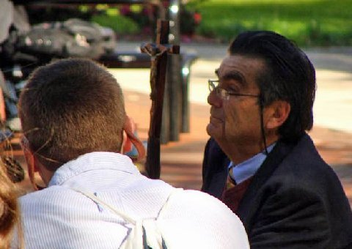
"If man is merely a late and insignificant byproduct of time, chance and matter, he lacks dignity and significance."
You pronounced, “Life is meaningless.” I asked, “Did you just make a meaningful statement?” You answered, “No.” Yet you had spoken as if you were saying something profound. And, you continuously asked me these last two days to clarify the meaning of my assertions. Why do you constantly ask me questions, if you are convinced that there are no meaningful answers? Or for that matter ask anyone else any questions. Why are you even in college? Why do people get so angry with me, if I am not saying anything meaningful? Your point of view renders your life meaningless. What kind of a philosophy of life is that? It is not a philosophy of life; it is a way of death. How do you interpret life, or anything for that matter?
Nick, there are spiritual counterparts to our five physical senses, without which our physical senses can deceive us. As I said (quoting Jesus) to the girl who appeared ready to strike me, who was restrained by her boyfriend, “You have eyes but you see not, You have ears but you hear not.”
So it is with you, Nick, you must see God with the eyes of your understanding. God’s voice is the voice of conscience and reason. Try listening to and acting on your conscience. I will give you credit that you do seem to be trying to exercise your rational faculty, more than most students. But as I have demonstrated, your statement that life is meaningless is a self-refuting statement. Therefore, it cannot be true.
“O taste and see that the LORD is good: blessed is the man that trusts in him (Psalm 34:8)” King David exclaimed in Psalm 119:103, “How sweet are your words to my taste! Yes, sweeter than honey to my mouth!”
Nick, approach God by faith and prayer; appeal to his promises; he will fulfill them; and you shall know as a result, that the Lord is righteous.
Jesus taught, “If anyone chooses to do God's will, he will find out whether my teaching comes from God or whether I speak on my own (John 7:17).”
God has placed within every man to know whether Christianity is true or false. The promises relative to the joys of life are the grand tests of Biblical revelation. These will be fulfilled to anyone, who with deep repentance and true faith turns unto the Lord. This is what is called experimental religion; the living, operative knowledge that a true believer has that he is passed from death unto life; that his sins are forgiven, the Spirit himself bearing witness with his spirit that he is a child of God. That he walks and talks with God.
Nick, reach out and touch the Lord; he is not far from any one of us.
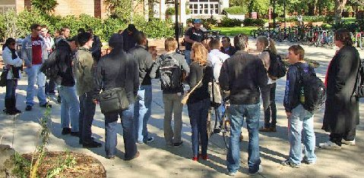
"Nick, reach out and touch the Lord; he is not far from any one of us. "

FaceBook Message from Kevin

Brother Jed,
I was out there with the crowd for a good while (3+ hrs), and I was one of the ones remaining when we ended. I just want to say that while I can't agree with your message, I commend you for what you're doing. To come out and preach to the college crowd, that's brave. You are helping to make college what it really should be: an open discussion/forum of ideas, where beliefs and opinions are traded civilly (for the most part), and people are exposed to a diverse range of ideas, and sometimes drawn to question their own. Please do come back again; I'll be there. By the way, you should know that even most of the people who argued with you the most don't think you're a "bad guy". In a different take on an age-old saying, they don't like the message, but they respect the messenger. Anyways, I wish you safe travels, and though I won't wish you success for spreading your message, I will wish you success on stimulating more thought-provoking intellectual debate and discussion.
Cheers,
Kevin
P.S. Feel free to quote any of this for whatever purpose, and if you wish to give credit, please only list my first name. Thank you.

Thank you for your faithful prayers and support. Please continue to pray for us. You may donate to CMUSA using PayPal by going to our web site brojed.org or by mailing your check to our home address: CMUSA 2402 Longview Dr. Columbia, MO 65203. All gifts are tax deductible. Thank you for your generosity

